Name - _______________________________________________________ Date - ________________
US History & Government
Review – Projects

Project #1 – Historical Figure Collage Due – May 13, 2013

Directions: Choose a historical figure from US History and create a creative collage with the following requirements:
- Have the historical figures name stand out prominently (include their full name and any nickname that might be appropriate).
- Include a minimum of 3 pictures – 1 must be of your figure; 1 must be done creatively and the last can be anything that would be associated with your historical figure.
- Include at least 4 adjectives that would be used to describe your historical figure’s actions, character, physical appearance and/or something they might be noted for.
- Include a specific historical event or era that they would be most noted for (may be more than one).
- Include a quote that would best describe your historical figure’s contribution to American History (can be a quote from them or about them).
- Write a 350 word write a descriptive essay detailing that event; include the write up on the back of the collage.
- Include a works cited page.

Project #2 - Supreme Court Cases Due – June 3, 2013

Directions: Create a PowerPoint for two landmark Supreme Court Cases. Make sure to be as creative as possible with your slide show (including backgrounds, fonts, & pictures).

- Choose 2 cases from the list below:
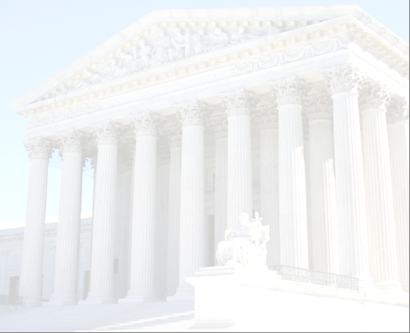
`

Marbury v. Madison (1803)
McCulloch v. Maryland (1819)
Gibbons v. Ogden (1824)
Worcester v. Georgia (1832)
Dred Scott v. Sanford (1857)
Civil Rights Cases (1883)
Wabash, St. Louis, & Pacific RRs v. Illinois (1886)
Plessy v. Ferguson (1896)
Northern Securities Co. v. US (1904)
Schenck v. US (1919)
Korematsu v. US (1944)
Brown v. Board of Ed, Topeka KN (1954)
Mapp v. Ohio (1966)
Baker v. Carr (1962)
Engel v. Vitale (1962)
Gideon v. Wainright (1963)
Escobedo v. Illinois (1964)
Miranda v. Arizona (1966)
Tinker v. Des Moines, IA (1969)
New York Times Co. vs. US (1971)
Roe v. Wade (1973)
US v. Nixon (1974)
Bakke v. Regents of the Univ. of California (1978)
New Jersey v. TLO (1985)
Hazelwood v. Kuhlmeier (1985)
Planned Parenthood, S.E. PA v. Casey (1992)
Veronia School District v. Acton (1995)
Falvo v. Owasso School District (2002)

- include in your PPT (one slide for each = at least 6 total slides)
A. Title and year of the case.
B. The background/history of the case.
C. The constitutional principles that were involved.
D. The decision (include the final vote & the Chief Justice at the time).
E. The impacts of the decision on US history.
F. Works Cited

*Be sure to cite your sources of information – APA Style – for both assignments. See Mr. deHaan’s teacher page for links to citation styles.*

