The officers from the Class of 2019 were on WBNG for its “Around the Tiers” news segment on Monday, January 15th. They did a great job! Go to www.wbng.com to watch their five minutes of fame!
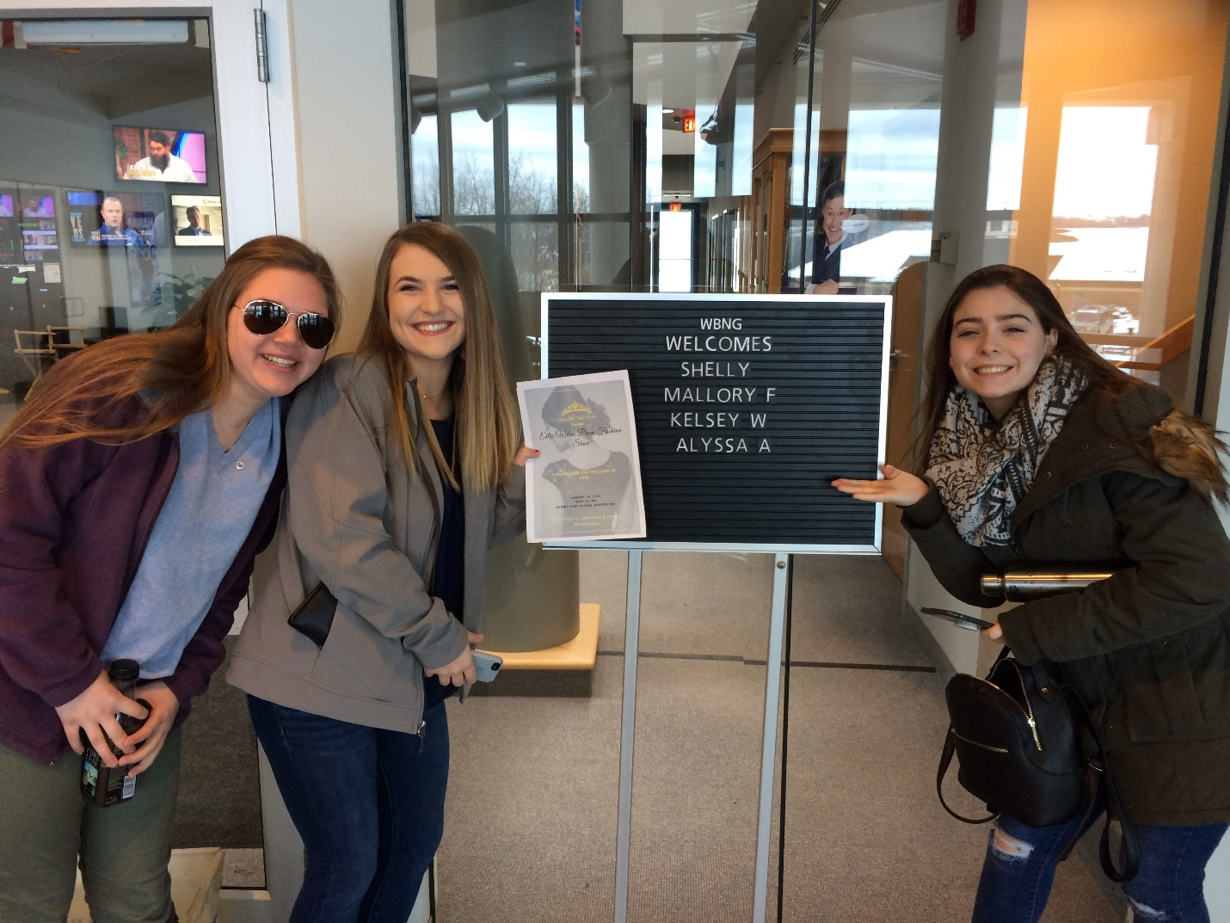

Please come out and support the Class of 2019 by attending the Ellie Wilde Prom Fashion Show! This event showcases many of our area businesses and is sure to be entertaining. Your $4 admission will get you into the show and you will be given 3 raffle tickets to put into various raffles. Addition raffle tickets will be available for purchase, including a $10 raffle ticket for a VIP prom experience sponsored by Cobble Creek Florist and Chenango County Coach. Come to the GCS auditorium on Saturday, January 20th from 10am-1pm to learn more!
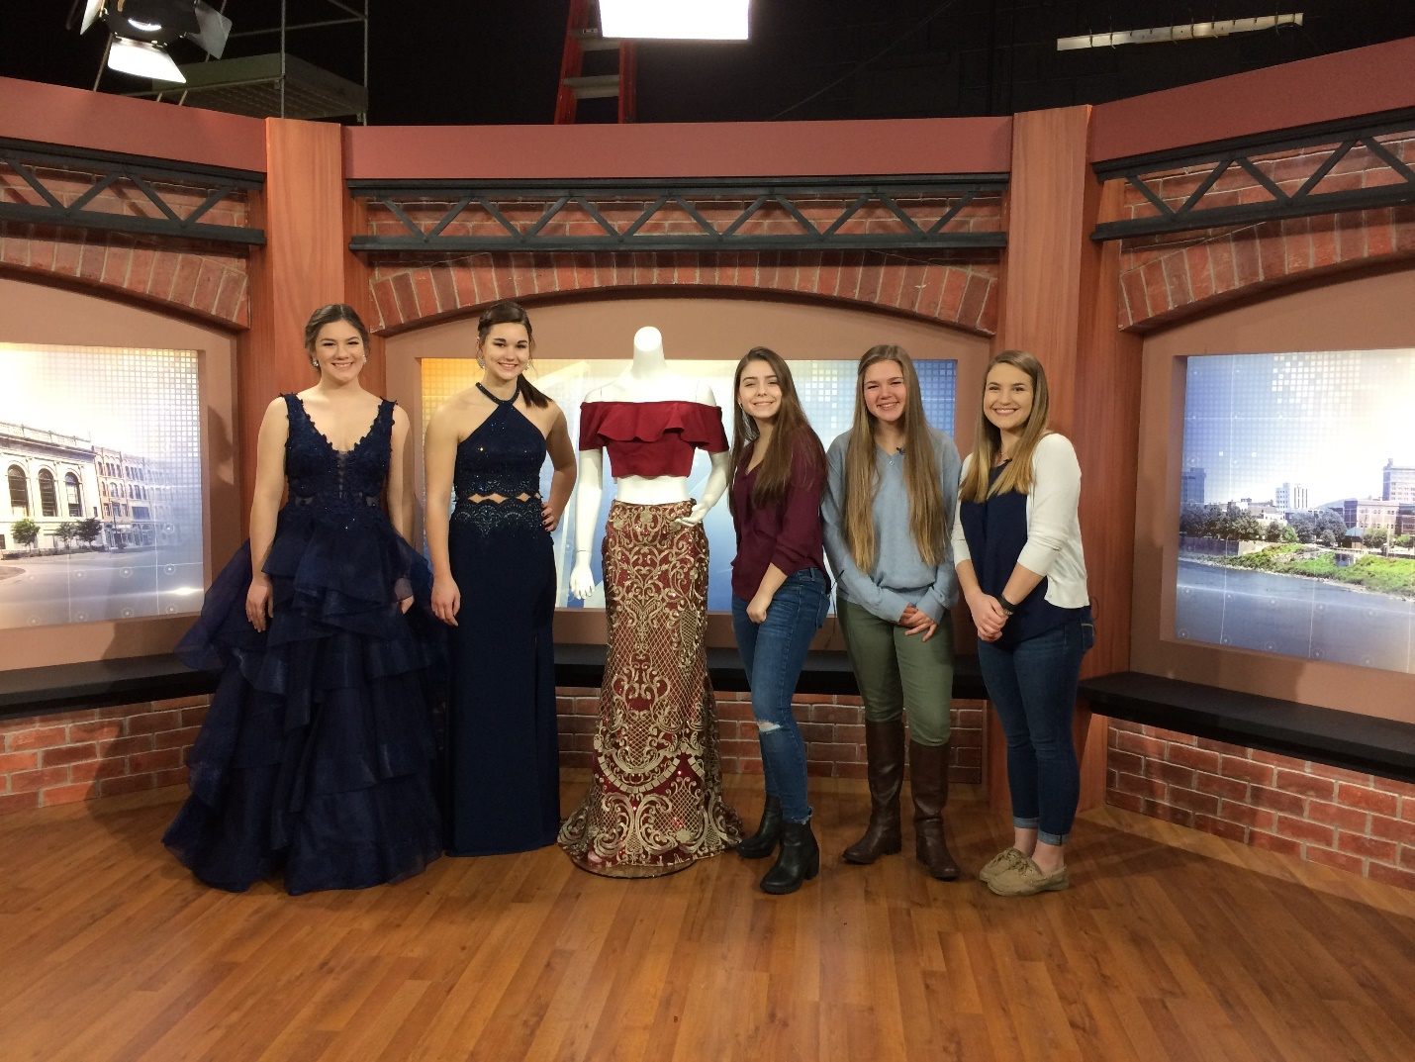

(Left to right): Bryanna Kinney, Emily Parker, Mallory Fowler, Kelsey Wahlers and Alyssa Acunto

