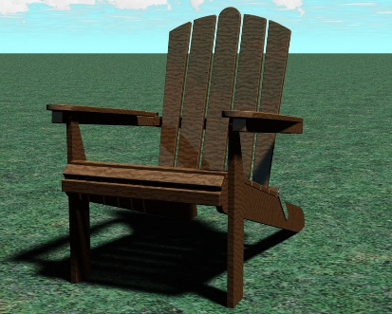Greene Intermediate School Adirondack Chair Application

Date of Request: ________________
Applicant Name: _____________________________________________________
Mailing Address of Applicant:___________________________________________
Phone of Applicant: ____________
Email of Applicant:_______________________________ _________

The cost of the chair is $75. Checks can be made out to Greene Central School
Return form to the Intermediate School Office.

During the spring of 2017, Greene Intermediate students worked with Mary Lake to design and paint Adirondack chairs with themes based around our core academic subjects. Some of these chairs will be placed throughout the school district and our community. There are 30 chairs that will be sold to community members for $75 each. If you would like to purchase a chair please fill out this application and turn it in to the Intermediate Office. The first 30 that are turned in will be guaranteed a chair. Every form after that will be placed on a waiting list. You will be informed by June 2nd if you are one of the first 30 or if you are on the waiting list. Payment for the chairs is then due on June 9th. If payment is not received by that date, a person on the waiting list will be contacted to purchase the chair. An assembly will be held on June 12th at 8:30 where all the chairs will be displayed and you can meet the artist. The 30 people that have bought the chairs will receive a number and will go in order from 1-30 to pick a chair. No one is guaranteed their top choice. The chairs can be taken home after the assembly June 12, 2017.

