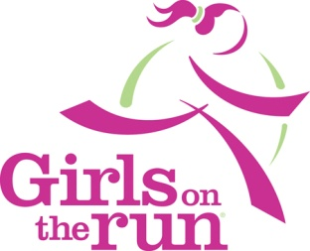
Girls on the Run of Central New York
Greene CSD
****** Register Online February 1st – February 14th******

Joyful…Healthy…Confident!!!
Girls on the Run of Central New York (GOTRCNY) is a local council of the national organization, Girls on the Run (GOTR). Two programs fall within the GOTR program, GOTR for girls in grades 3-5 and Heart and Sole for girls in grades 6-8. GOTR/H&S teach life skills using interactive curriculum and running to build self-esteem and inspire self-respect in preteen girls. We meet twice a week after school for 10 weeks in teams of no more than 15 girls. Lessons from the curriculum provide girls with the tools to make decisions to choose a healthy lifestyle and engage in regular physical activity. All groups are facilitated by trained, volunteer coaches.

Registration, Fees and Team Selection Process
This year, we are happy to offer programs for girls in grades 3-5 for the third year! Registration will open on February 1st at 7 a.m. and will run until February 14th at 11 p.m. Registration will be a lottery system, so participants can sign up any time during that period. Please visit the website www.girlsontheruncny.org for the link to the online registration form and for additional registration information.

Meeting Dates and Times
Monday/Thursday 3:00-4:30
Program begins week of March 16th

Program Fees
Program fees cover all materials, coach training, 2 t-shirts for each girl, enrollment in the Cooperstown 5k, and any additional supplies needed for the program. There is a sliding fee cost for this program, as outlined below:

Household Income Greater than $30,000 -- $90.00 fee ($4.50/lesson)
Household Income Under $30,000 -- $60.00 fee ($3.00/lesson)
Free/Reduced Lunch Program -- $30.00 ($1.50/lesson)

NO girl is turned away from the program because of financial hardship. Please call Mrs. Williams or Mrs. Bailey as soon as possible for information on scholarship options if cost is a hardship.

Key Dates
February 1st -14th – Online lottery registration begins at 7 a.m. and ends at 11 p.m. on the 14th.
Week of March 16th – GOTRCNY Season begins!!! You will receive information about the program (coach names, meeting place, etc.) before the start date.
Sunday, June 7th – GOTRCNY Celebratory 5k Event in Cooperstown, NY (open to the public—you, too can register!!)
www.girlsontheruncny.org

Contact any of us…Sunnie Williams at ext 535 or slwilla@greenecsd.org, Lorene Sanderson at ext 531 lsanders@greenecsd.org, or Pam Bailey at ext 685 or pbailey@greenecsd.org

