“Read To Ride”

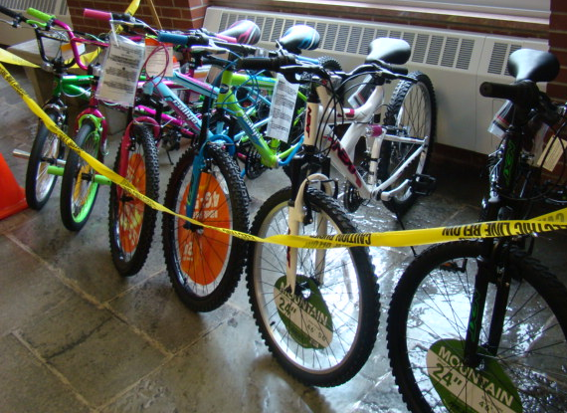
The Intermediate building is once again having bikes donated by Kay Borne for our “Read to Ride” reading incentive program. Each child will get a chance to win a new bike and helmet with every 10 books they read. Along with the bikes, there will be smaller prizes donated by the PTO, Mrs. Borne and Greene Central School. Please encourage your son or daughter to keep reading. The winners will be drawn on field days in June.
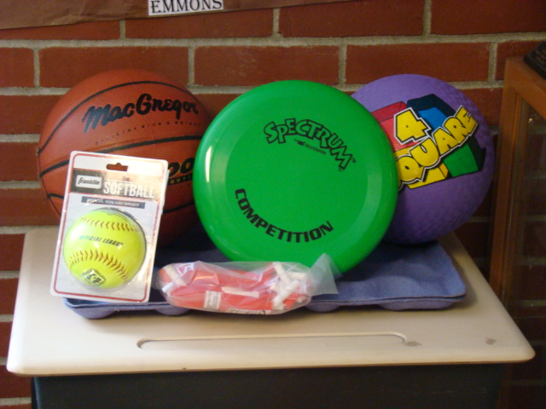

These are the proud bike winners from Field Days 2016!

