Discovery Night
By Ethan Leet Physics Teacher at Greene Central School
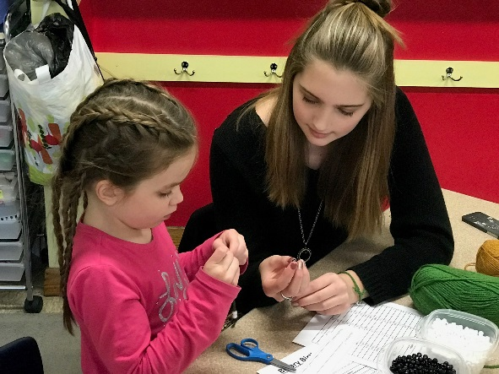
Wednesday, March 22nd, 2017 Greene Central School hosted Discovery Night at the Intermediate Campus. There were over 400 parents and students in attendance. There were over 100 staff and students that provided activities for younger students and their parents.
This year there were a lot more High School and Middle School students hosting activities for the younger Intermediate and Primary students. The younger students seem to respond very well to working with the older students. The older students got a chance to give back to their community.
Figure 1
High School student working with
Primary student at Discovery Night.
Discovery Night brings all community members together. Parents and family members did activities with their children. Parents and family members got a chance to work with teachers. Teachers got a chance to reach more students than in their normal class setting. The student to student interactions help to make a closer community here in Greene. The student to parent interaction helps to promote that education is important. Discovery Night is a fun educational evening for the entire community.
Thank you to the Intermediate for hosting the event. Thank you to the teachers that put together activites for Greene’s younger students. Thank you to the district for the support in hosting the event. Thank you to Greene’s Community for attending the event.
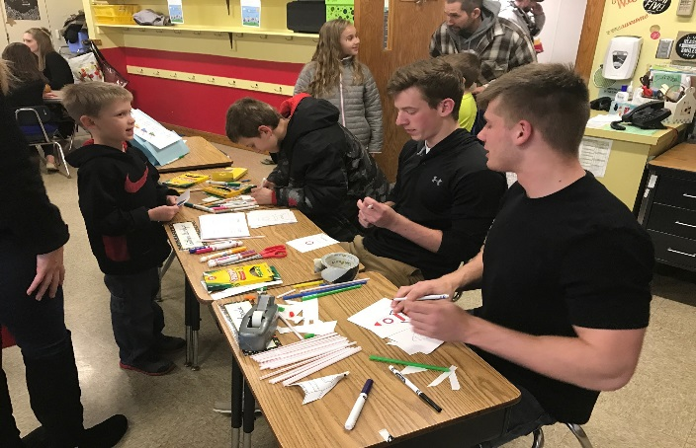  Figure 2  High school students working with younger K-5 students to make art projects. | 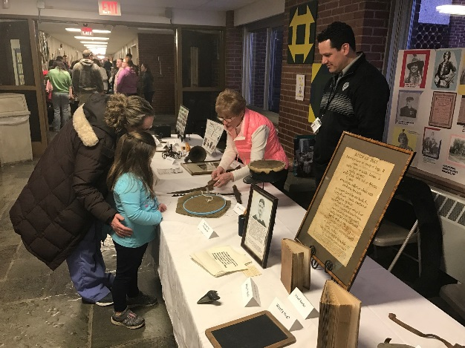  Figure 3  Greene’s Historical Society teaching history to students.
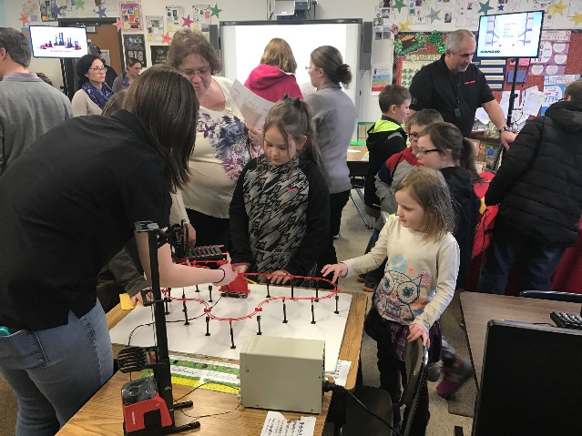  Figure 4  Raymond showing their 3D printed Roller Coaster. | 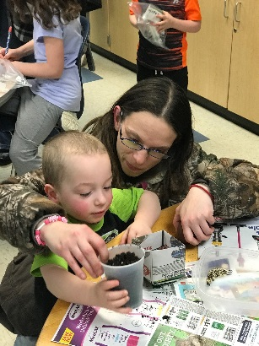  Figure 5  Parent and child making compostable planters.

